## INBOX

The **Inbox** works similarly to most email applications. In the HIE, a user’s Direct address is that user’s HIE username followed by the system’s Direct Messaging address. For example, user “John_Smith” would be “John_Smith@direct.[HIE Domain Name].com”.

The upper right of the **Inbox** screen shows the Direct address of the user whose mailbox is currently displayed.

There are three folders which store direct messages: **Inbox**, **Sent**, and **Deleted**. Click on any of the folder names to access those folders.

Click the refresh button to check for new messages. To delete a message from a mailbox, select the checkbox beside the message and click the trashcan button.

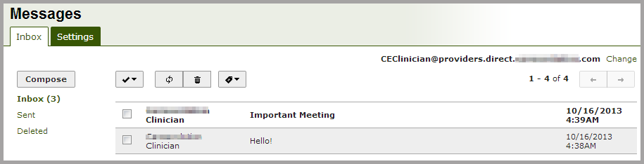

### MDN Messages

MDNs (Message Disposition Notifications) are special messages that contain information about the receipt status of Direct messages. MDNs are required by the Direct protocol, and can help diagnose message delivery issues.

When a Direct message sent from an inbox, the recipient’s Direct server responds with an MDN, indicating the message’s receipt status. These statuses are defined as follows:

* Processed MDN: indicates that a message has been received by the recipient’s system.
* Dispatched MDN: indicates a message has been delivered to the recipient.
* Failed MDN: indicates that a message has not been delivered to the recipient.

To hide MDN messages in your inbox, click on the tag button on the far right of the inbox toolbar, and select an option from the drop-down menu. Clicking on one of the check boxes will hide all messages of that MDN type.

To show MDN messages that have been previously hidden, uncheck the appropriate checkbox.

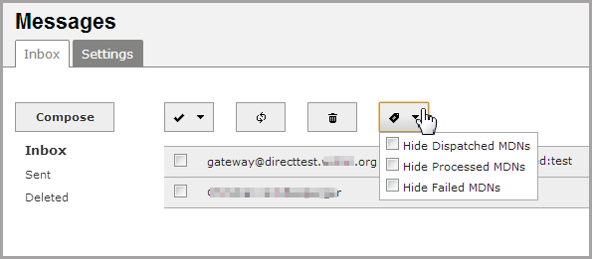

### Composing Direct Messages

Click the **Compose** button to begin writing a new message.

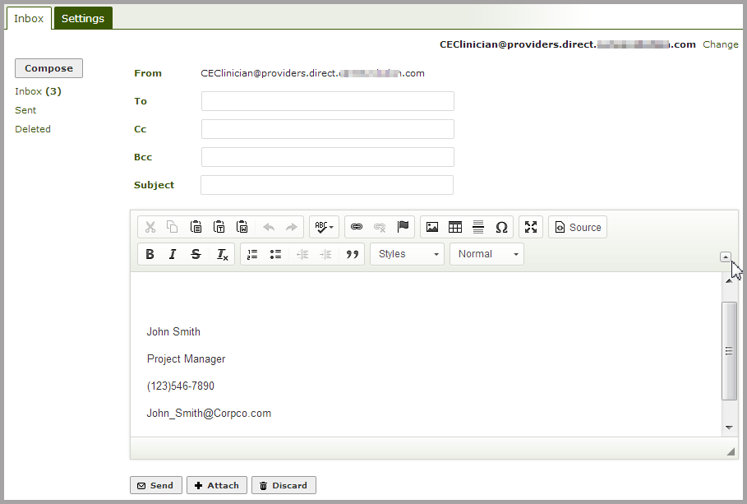

To address the message, begin typing the first or last name of the recipient. As you begin typing, the autocomplete feature will suggest matching Direct users within your HIE directory. Click on the correct name and address to add it to the list of recipients. If you are sending to an external Direct user, type in the Direct email address and press the enter key to add it to the list of recipients.

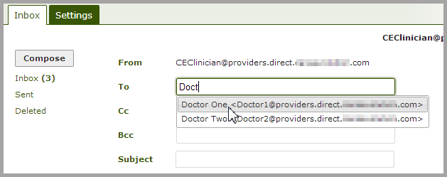

If the system cannot verify the Direct address, it will appear in red.

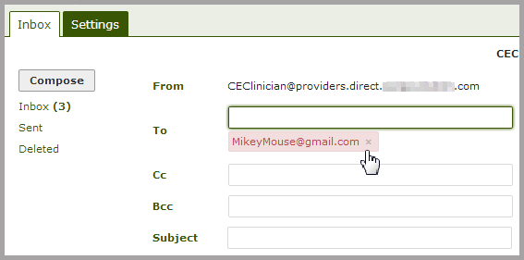

You will now see the selected address displayed below the **To** field. Click the **x** to remove an address. You may send to as many other recipients as appropriate as a To, Cc or Bcc.

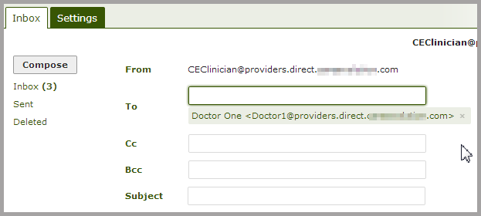

The toolbar contains tools for editing and customizing messages. A tooltip will appear when hovering the cursor over a toolbar icon. Collapse or expand the toolbar by clicking the arrow icon on the lower right.

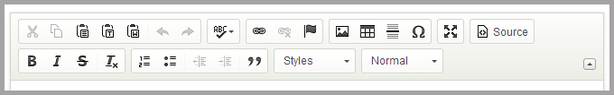

If you have created a signature (see **Settings** tab), it will automatically appear in the body of the message.

